
Thando sthe pty ltd
Boitumelo Queen Lebepe-ST10527363

April 11, 2026
Web development 5020
Thando Sthe Pty Ltd Proposal 2

Contents
Thando Sthe Pty Ltd 1
Background Information 2
Target audience 2
KPI (Key Performance Indicators) 2
Website goals and objectives 3
Objectives 3
Current website analysis 3
However, this also presents an opportunity to: 4
Proposed website features and functionality: 4
Design and User Experience: 4
User Experience: 4
Technical Requirements: 4
Project Planning Timeline 5
Budget 6
Logo: 6
Wireframe: 7

Thando Sthe Pty Ltd

Background Information
Thando Sthe Pty Ltd is a South African supply and services company providing office stationery, general business supplies, office furniture, and office branding solutions. We also offer professional cleaning services, including office cleaning, once-off deep cleaning, and post-event cleaning.
Our goal is to help businesses operate efficiently by delivering reliable products, quality cleaning services, and flexible solutions tailored to each client’s needs.
Mission Statement
Our mission is to provide high-quality bulk supplies, cleaning products, stationery and furniture all in one place. We are committed to delivering reliable service and building lasting relationships with our customers. We strive to be a one-stop solution that support businesses, schools and households with efficiency, consistency and care.
Vision statement
Our vision is to become the leading, preferred and trusted supplier in our community and beyond, recognised for excellence, affordability and outstanding customer service. We aim to grow sustainably while continuously adapting to meet the evolving needs of our client’s.

Target audience
- People who own large companies/businesses
- Households
- Schools
- Small businesses

KPI (Key Performance Indicators)
- Grow social media followers by at least 30%
- Achieve an average engagement rate of at least 25% per post over 6 weeks.
- Receive at least 20 orders via the website
- Increase customer enquiries through the website by 40% for the next 3 months.
S- Focuses on customer engagement
M- Less than 50% increase
A-Realistic for a growing business without a website
R- social media is currently the main platform
T-Time bound-3 months

Website goals and objectives

- Establish a professional online presence for the business
- Showcase services such as office branding and corporate identity solutions
- Generate new leads and client enquiries, and provide easy access to contact details and business information
- Developing a website for the business will significantly improve its market presence and customer reach.

Objectives
- Increase customer engagement
- Improve brand visibility in search engines
- Encourage potential clients to request quotes
- Increase the businesses online presence

Current website analysis
Currently the business does not have an online presence or website rather. Therefore, this creates the following challenges:
- Limited online visibility
- Loss of potential clients searching online
- Lack of credibility compared to competitors with websites
- No central platform to display services and past work.
- Weak customer base or target audience rather

However, this also presents an opportunity to:
- Build a modern website from scratch
- Implement the latest design trends and technologies
- Align the website fully with the brand identity

Proposed website features and functionality:
- Homepage: Overview of the business and services
- About us page: Company background and mission
- Services page: Detailed description of offerings
- Shopping and checkout: This page will display the purchasing of products
- Learn more: This page will give more detail about the business and its mission and how to contact them.
- Navigation bar: To improve the user experience
- Buttons: To link users to the desired page they wish to engage with or quicker access rather.
- Search Engine Optimisation: Improve visibility on Google

Design and User Experience:

- Elegant colour scheme (navy blue, grey and white)
- Clean and modern layout and professional typography
- High-quality images of completed work

User Experience:

- Easy navigation with clear menus
- Fast loading speed
- Simple and intuitive layout

Technical Requirements:

- Domain name: e.g. www.thandosthe.co.za
- Web hosting: Reliable hosting service
- Basic SEO tools
- Security: SSL certificate for secure browsing
- Responsive Design Tools: For mobile compatibility
- HTML will be used to create the skeleton of the website (Part 1 of the assignment)

Project Planning Timeline

Week 1, 26 March-31 March
Selection of a business. Research about the business. Content sourcing. Planning
Gather the references

Week 2, 01 April-04 April
Creation of Github account and the repository. Planning and creation of a sitemap

Week 2,06 April-8 April
Planning and creation of the of the 2 proposals.

Week3, 09 April-10 April
Creation of the wireframes required

Week 3, 11 April
Submission of the two proposals (Awaiting response/feedback)

Week 3, 12 April -15 April
Begin on one website (HTML code)

Week 4, 16 April-18 April
Completion of the website
Test the website on various web browsers

Week 4, 18 April
Submit of the Github repository.
Complete the READme Document

Week 5,19 April
Push the website of Github and create commits

Week 5, 19 April
Completion of part 1 assignment-Submit part 1 assignment

Budget
Domain registration: R150-R300 (per year)
Web Hosting (per year): R1000-R2500
Web Design and Development: R3000-R8000
Maintenance(optional): R500-R1000
Total estimated cost: R4650- R11800

Logo:
The following image displays the logo of the business:
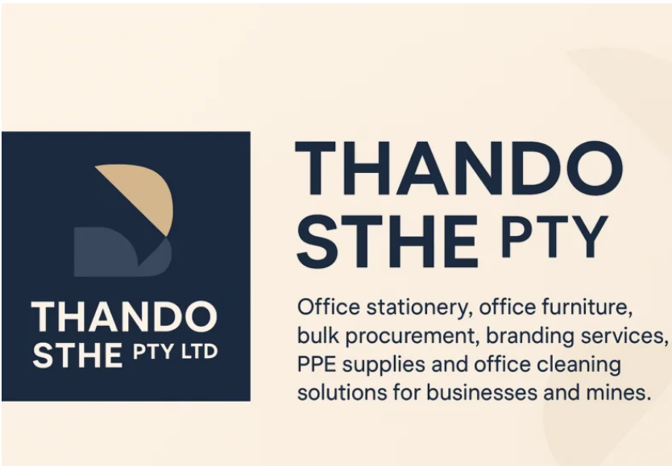

Wireframe:
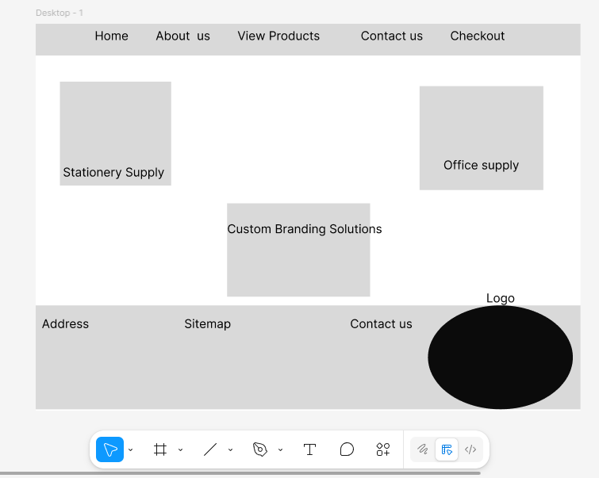
Name of the business

References List:
[Headphone Expert] [Comfortable office chairs worth every penny [Accessed on 19 April 2026] Available at: | https://pin.it/2En383A4F
[Amercis OF] Premium leather office chairs [Accessed on 19 April 2026] Available at: | https://pin.it/6VUqQI6mU
[Eureka ergonomics] Serene Ella, Genuine Leather Executive Office Chair [Accessed on 19 April 2026] Available at: | https://pin.it/n455B8Oeu
[Pourkazem] Costa Executive Desk from Iconic office Furniture [Accessed on 19 April 2026] Available at: | https://pin.it/2kxjLySKC
[ Edel Alegre] Modular Cabin Table Manufacturer and Supply [Accessed on 19 April 2026] Available at: | https://pin.it/LEuBsF6Q0
[Shopee Indonesia] Back to school supplies Essentials [Accessed on 19 April 2026] Available at: | https://pin.it/ISZLpYBuH
[Supply Concepts, Inc] Office furniture | Supply [Accessed on 19 April 2026] Available at: | https://pin.it/2Ss2gFISu
[Stock Adobe] Set of office objects [Accessed on 19 April 2026] Available at: | https://pin.it/6dYJIDfBM
[Etsy]Cleaning supplies Kit-Practical housewarming Gift Basket [Accessed on 19 April 2026] Available at: | https://pin.it/6ZaMlc0Fw
[Shein]Blank Cards suitable for Business Cards {Accessed on 19 April 2026] Available at: | https://pin.it/5pIl9H8b0
[Shadow Breeze | Custom Curated Corporate Gifts] Same-Day Bulk branded Corporate Gifts for employees and clients [Accessed on 19April 2026] Available at: | https://pin.it/6wgWApvoa
[Displays to go] Roller Banner stands for a single-sided graphic (not included) [Accessed on 19 April 2026] Available at: | https://pin.it/12Efe4UEE
[bespokesport7] We are professional manufacturer and supplier all kind of sportswear (…)[Accessed on 19 April 2026] Available at: | https://pin.it/PNgzCwkZj

